Creating and linking an ANVGL account

This guide will show you how to create and configure an ANVGL account.

# Prerequisites

ANVGL requires you to have a Google email account for authentication as well as Amazon AWS account for executing jobs.

# Creating an ANVGL account

In order to create an ANVGL account, please go to the ANVGL website and select “Login” from the top menu bar.

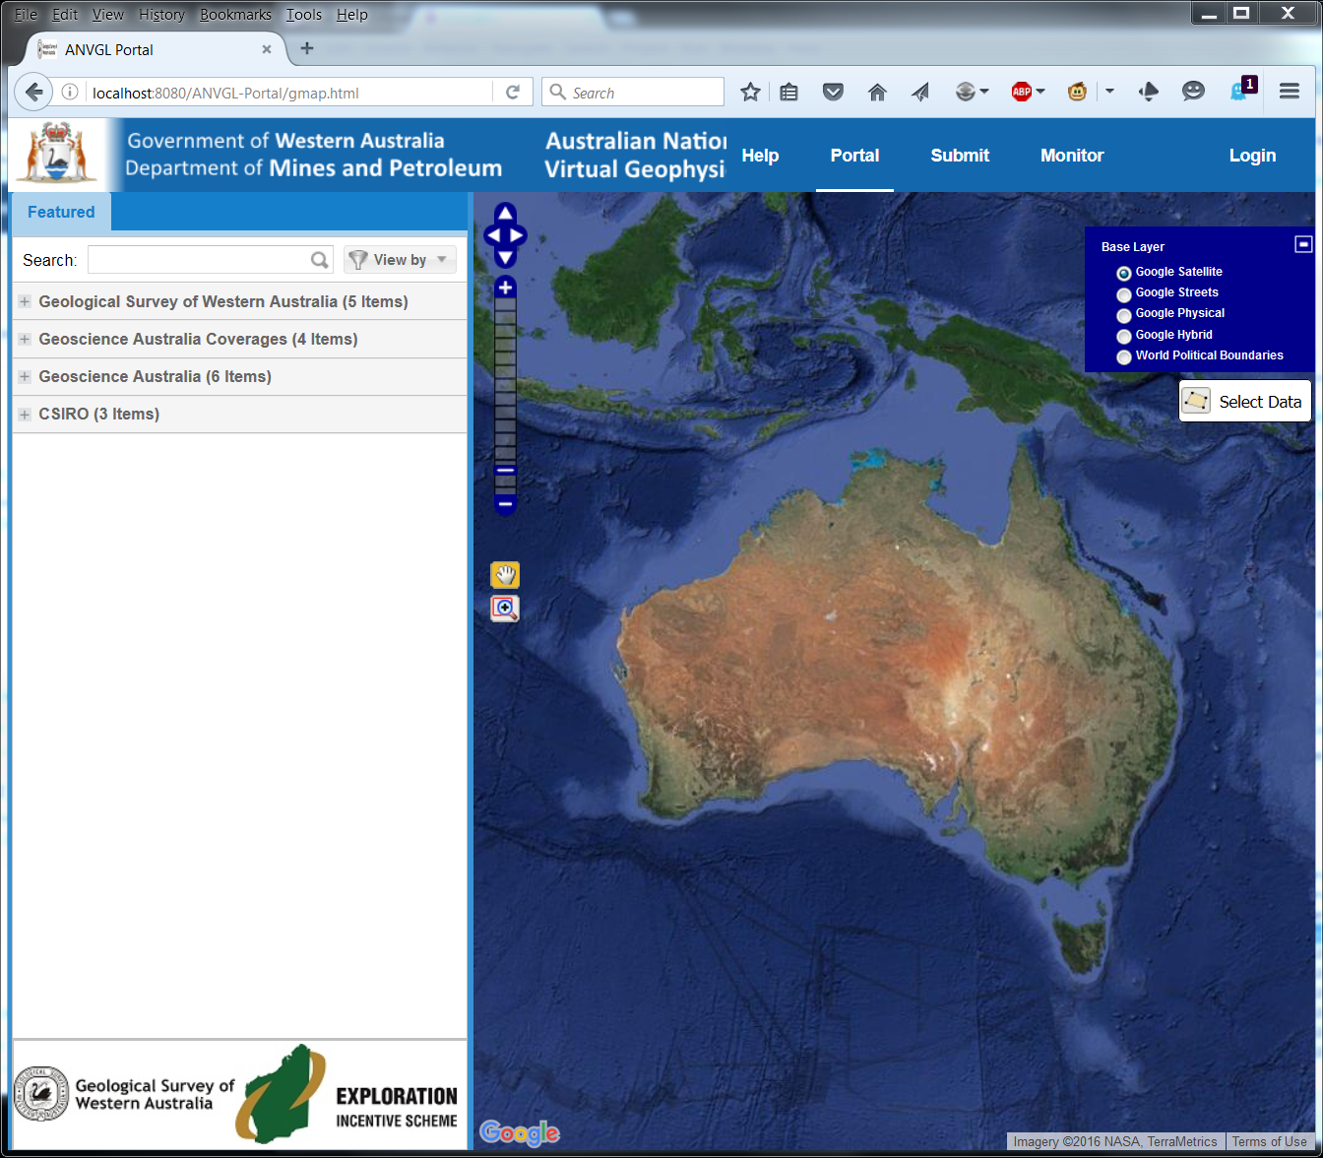

This will redirect you to Google where you have to log in with your Google account and allow Google to authenticate you on request by ANVGL.

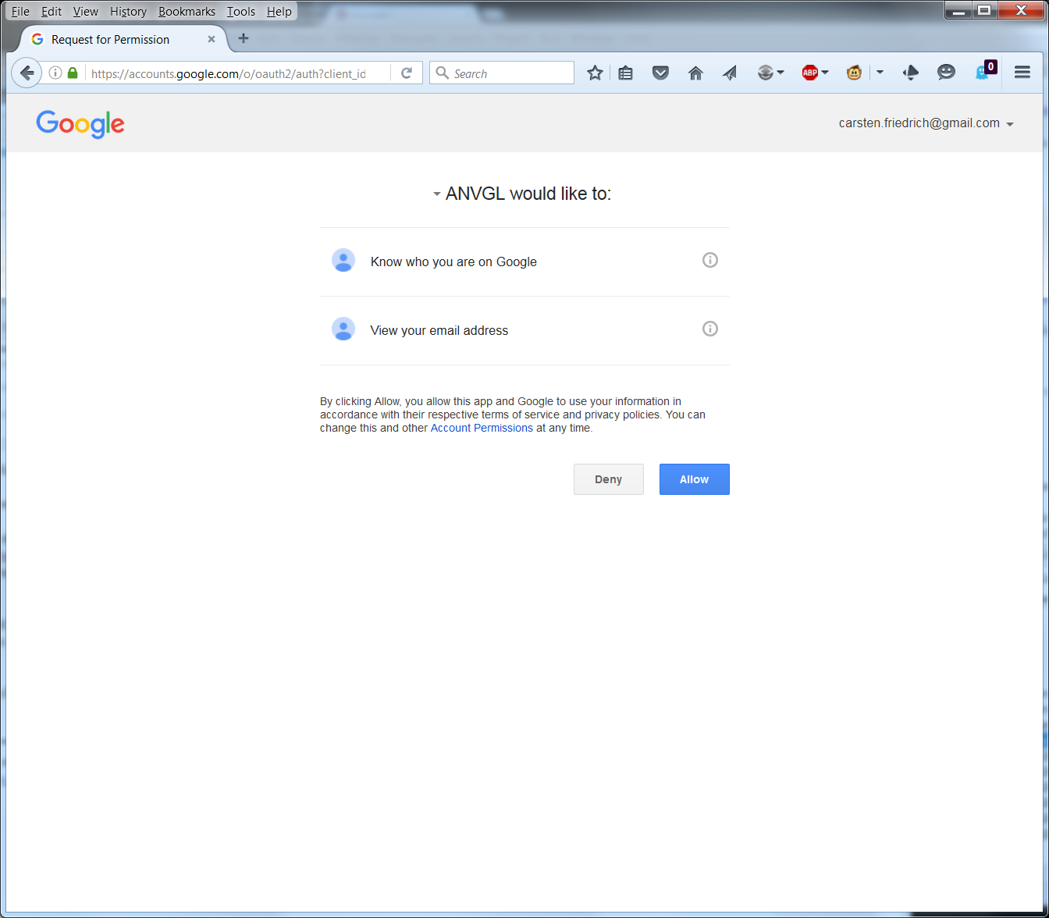

After pressing “Allow” at Google, you will be redirected back to ANVGL where you are asked to accept the ANVGL terms and conditions of use.

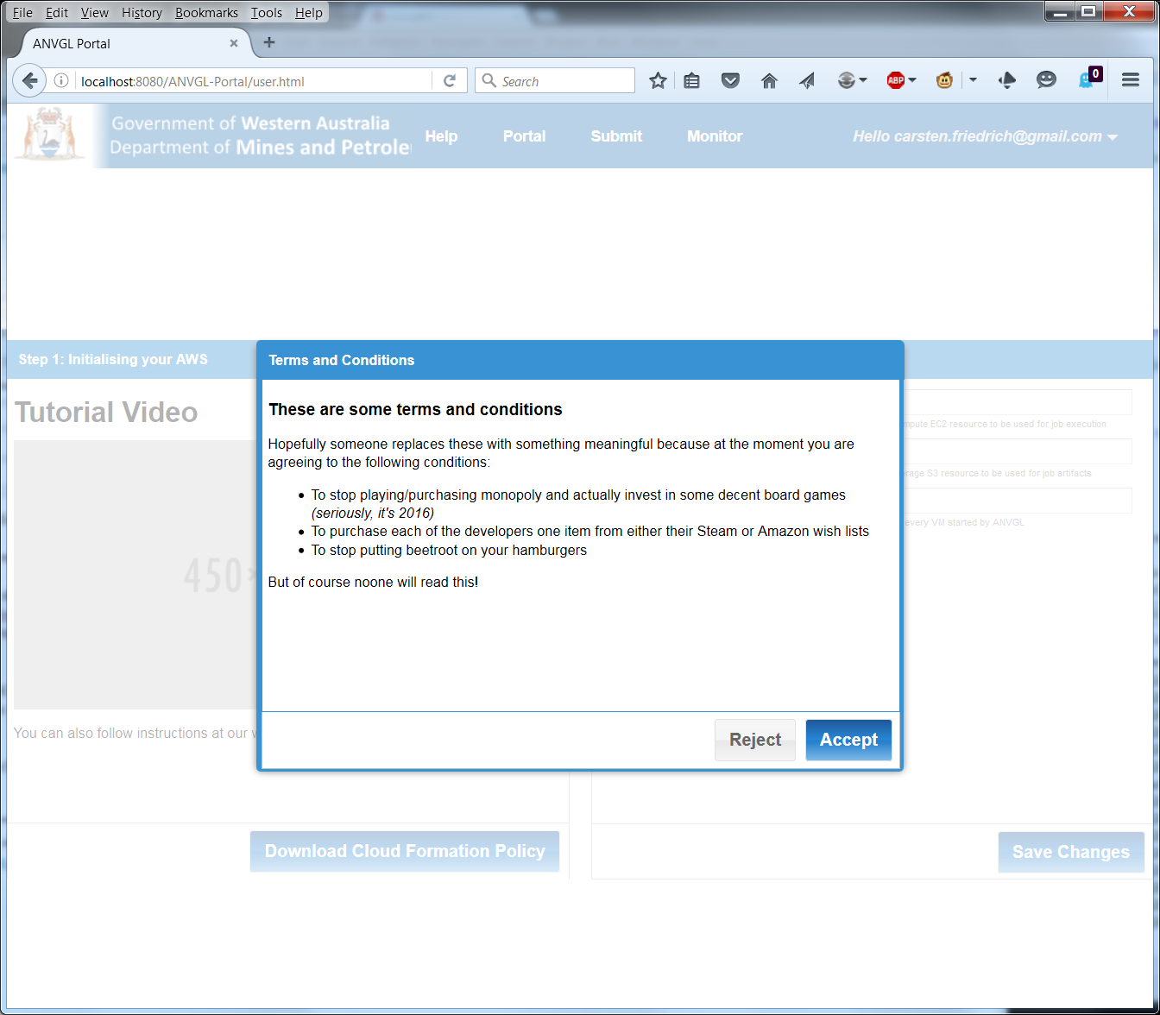

After accepting ANVGL terms and conditions you will be asked to link an AWS account against your ANVGL account. By doing so all jobs you start in ANVGL will run under your AWS account. Also, all costs associated with running the job will be billed against you AWS by Amazon.

To start, press the button “Download Cloud Formation Policy”. Save this document to your local file system.

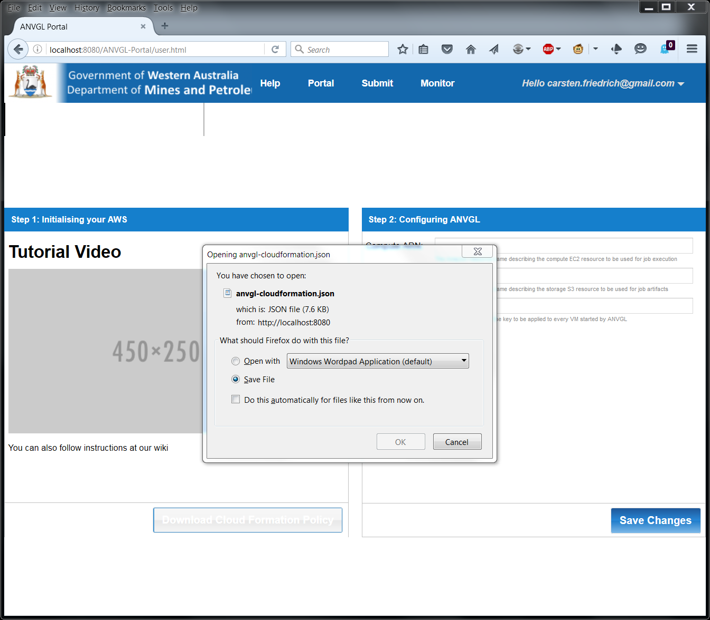

Please now go to the Amazon web site and log into your AWS account. Once logged into AWS select the “Cloud Formation” service. Press the button “Create New Stack”.

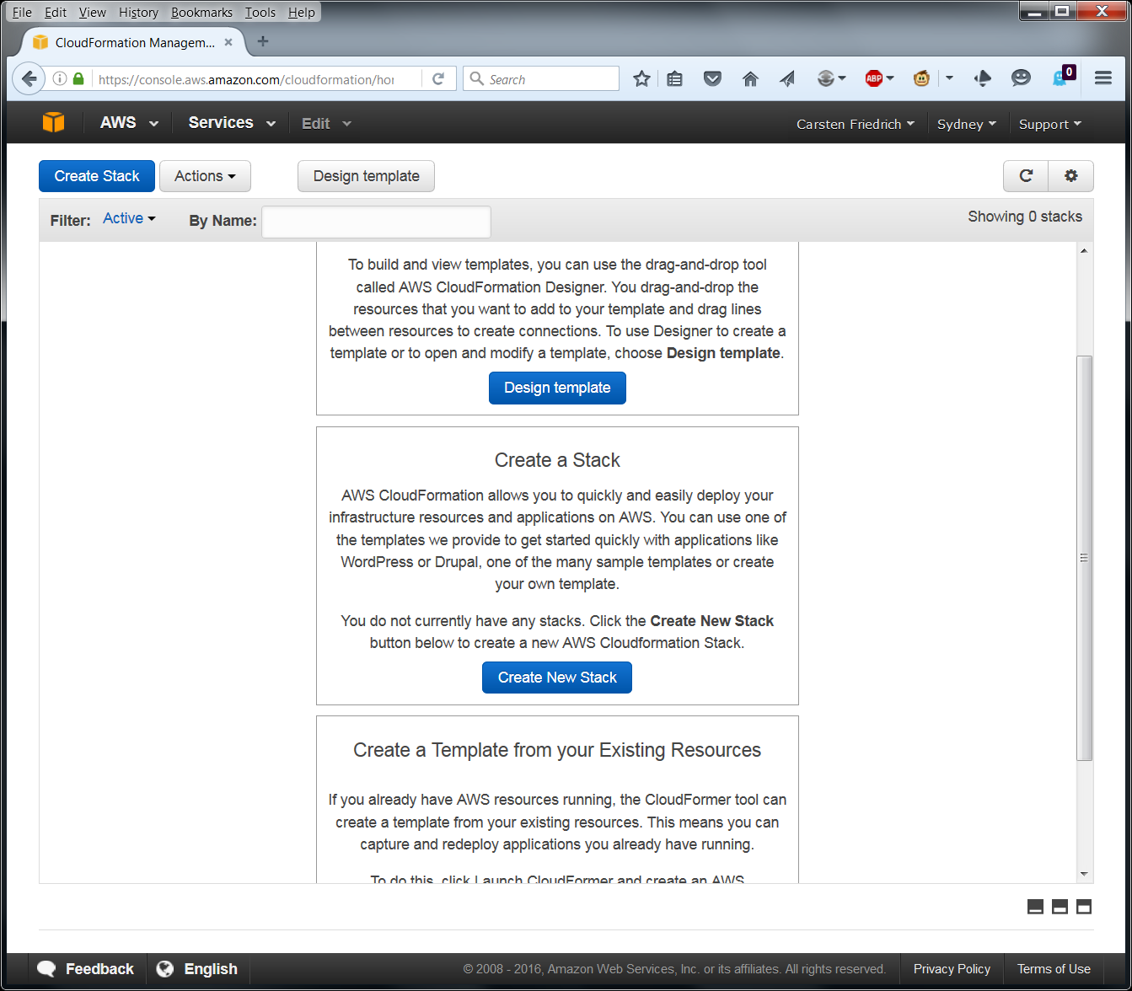

Select the option “Upload a template to Amazon S3”. Press the button “Browse” just below that and locate the file you just downloaded from ANVGL. Then press “Next”.

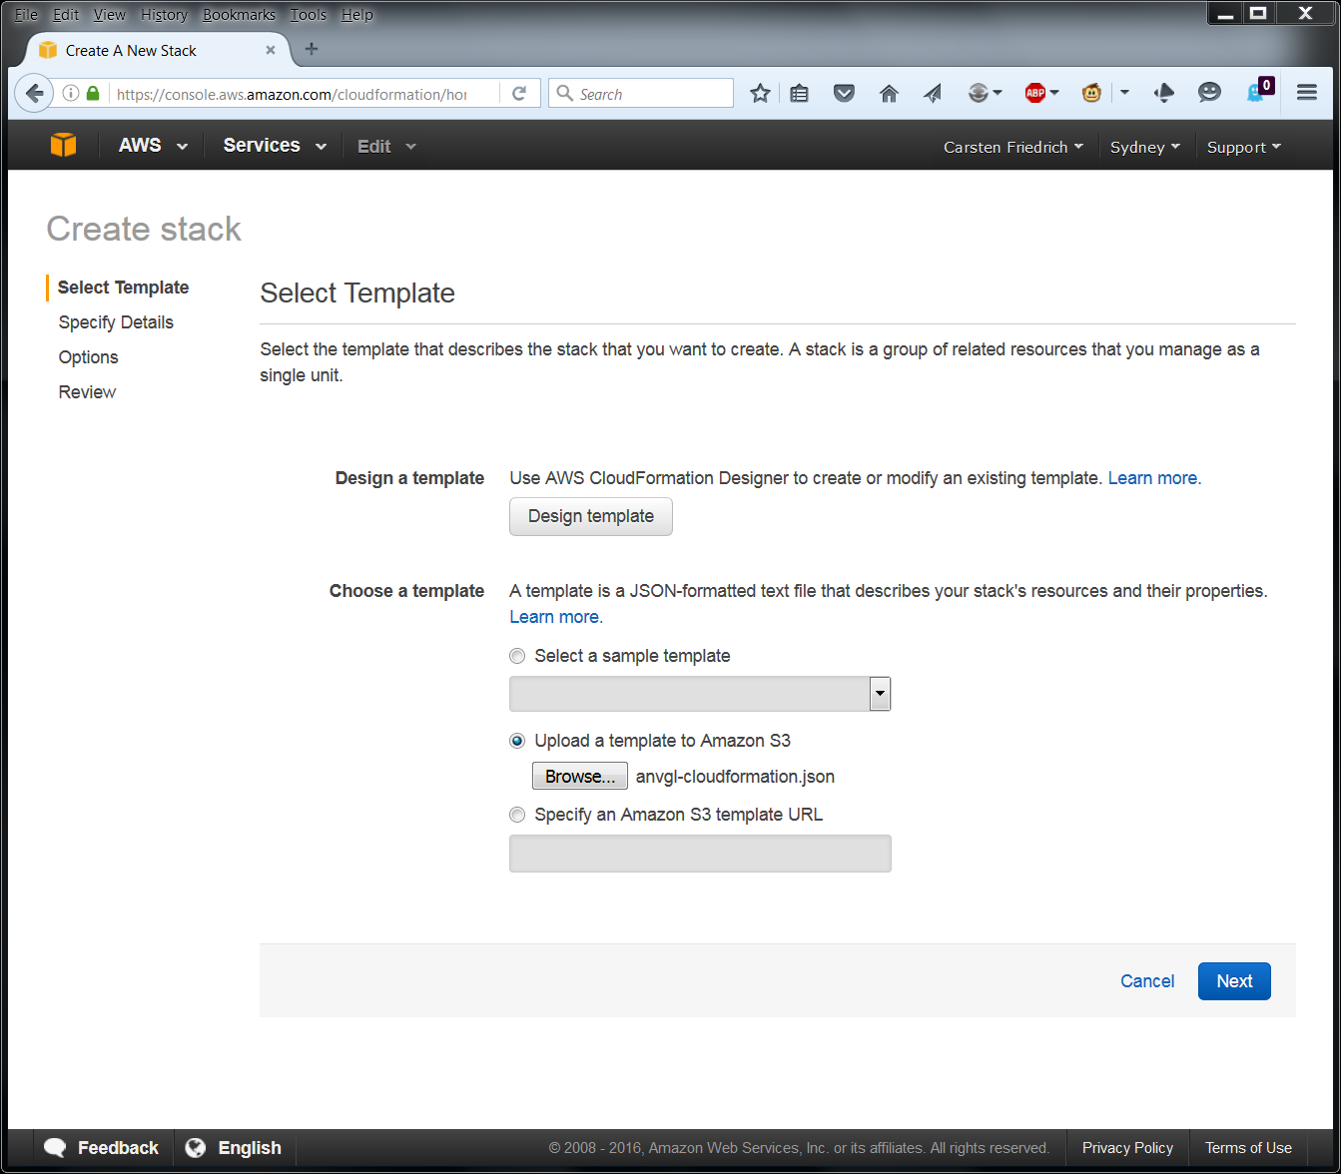

In the next screen enter a name for the stack that will be created. It does not matter what name you choose, but we recommend using a name which is in some way associated to ANVGL.

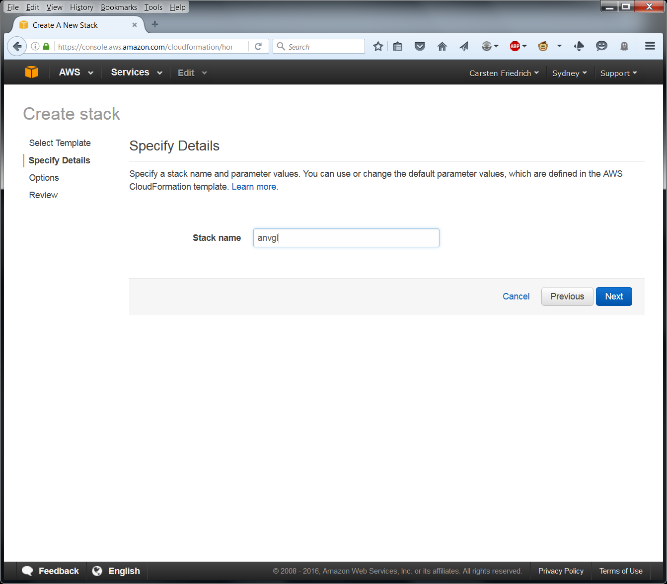

In the next screen (Options) just press “Next”.

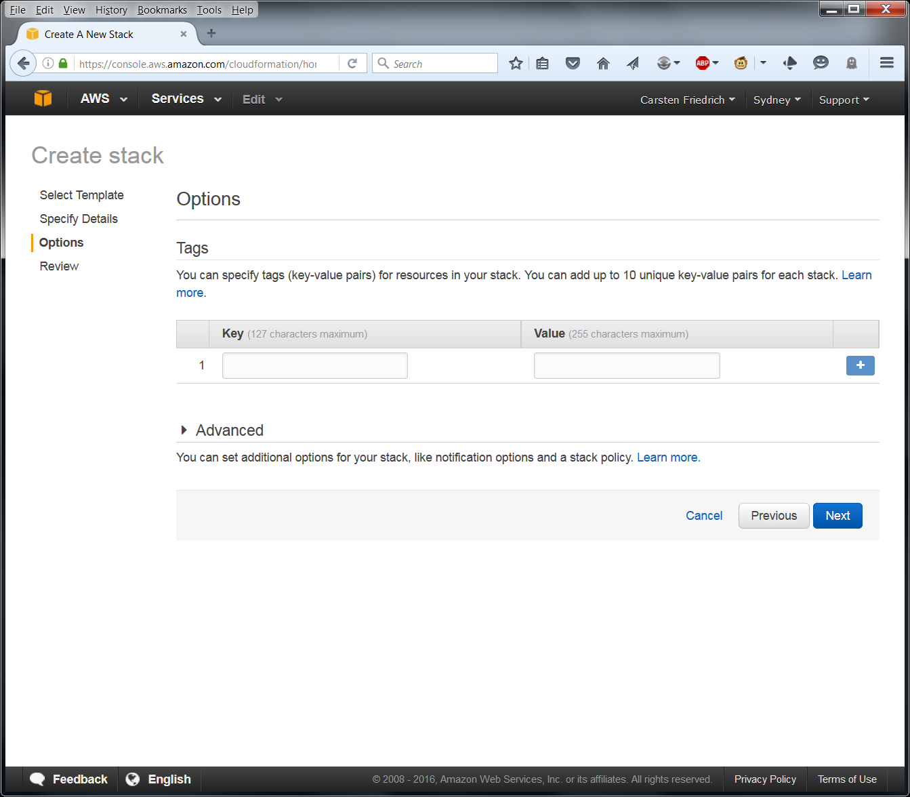

In the next screen tick the acknowledge box and press “Next”.

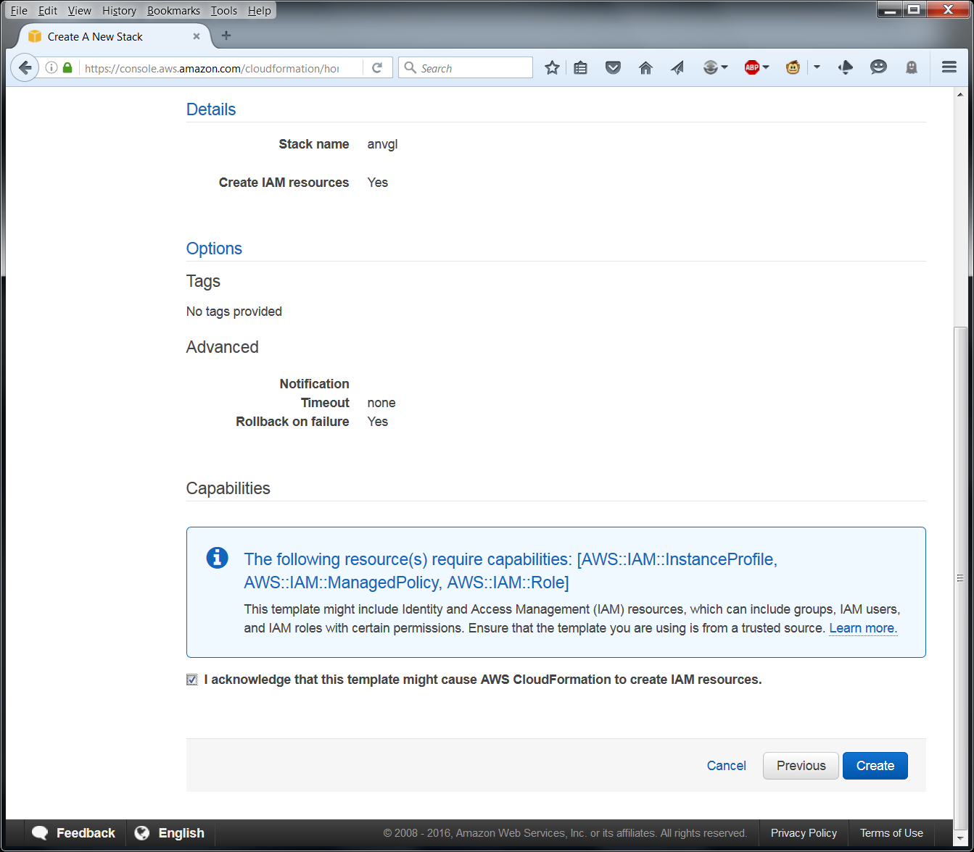

AWS will now create the roles and policies that are required to ANVGL. Once the process finished you should see a green label reading “CREATE COMPLETE” (you might have to manually press the “refresh” button for this to appear).

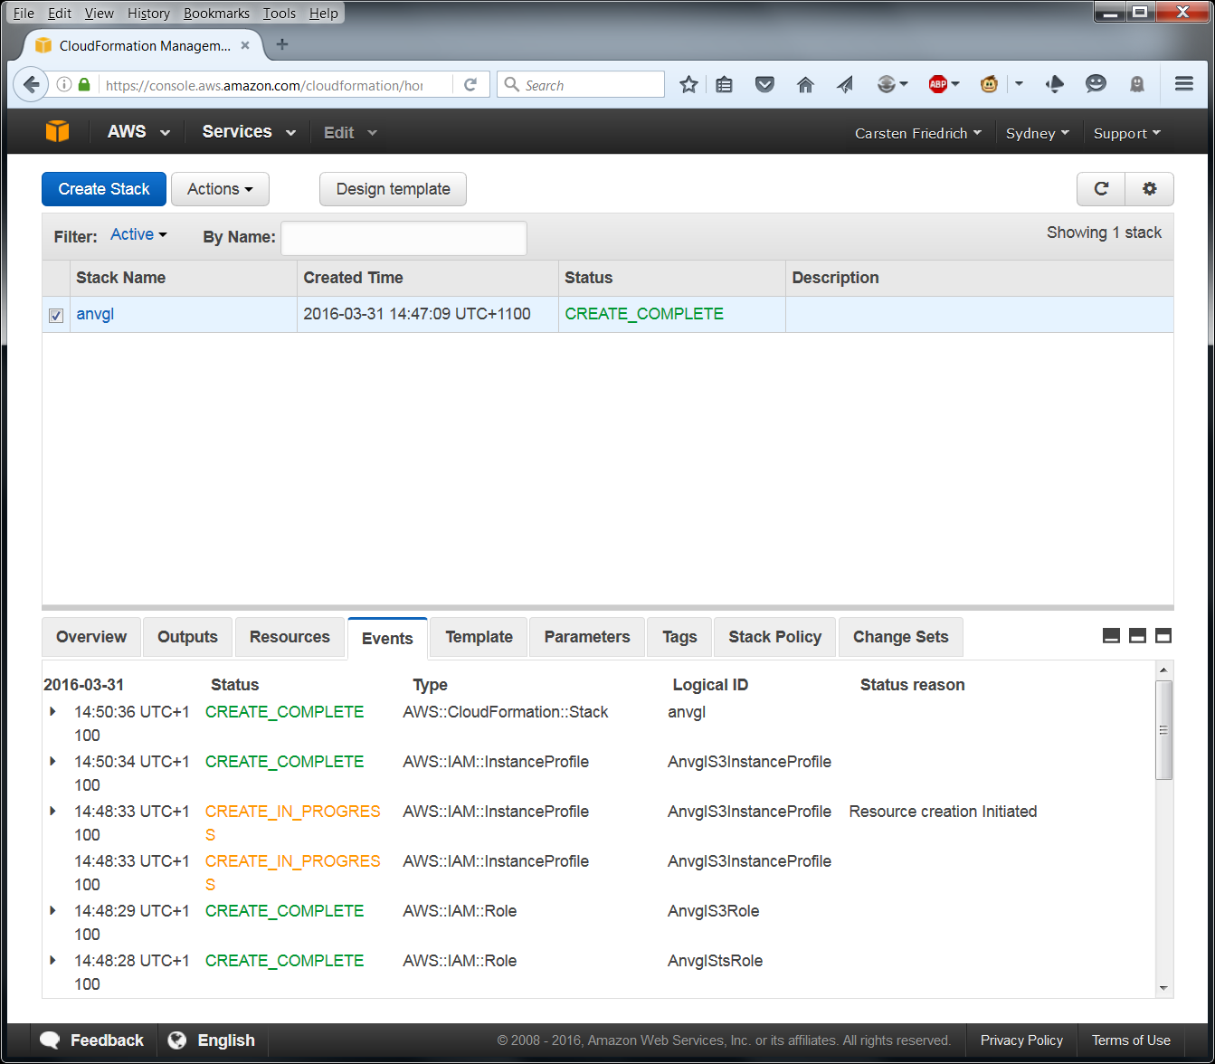

Please switch to the “AIM” service now in the service menu. You should see 2 newly created roles. Their exact names will differ slightly from the screenshot below. 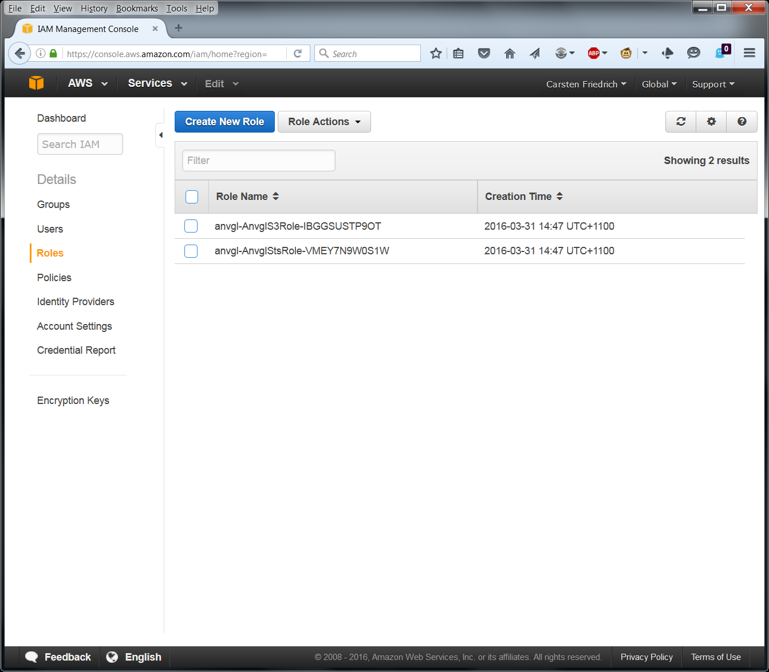

First select the role which contains the string “-AnvglS3Role-“. Select the value for “Instance Profile ARN” and paste it into the field “Storage ARN” in ANVGL.

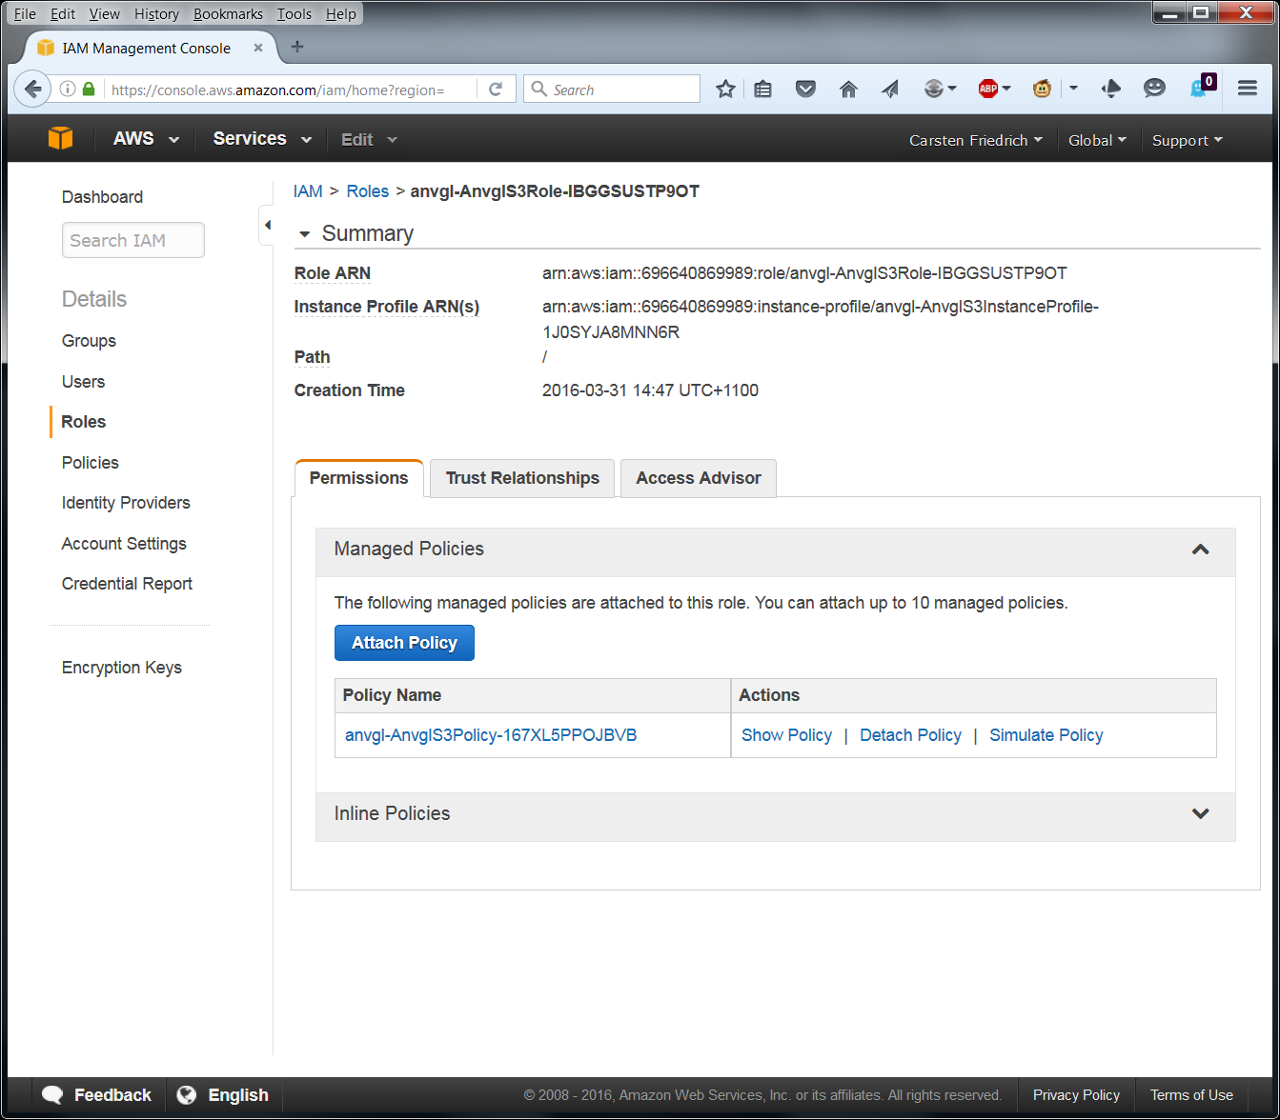

Then select the role which contains the string “-AnvglStsRole-“. Select the value for “Role ARN” and paste it into the field “Compute ARN” in ANVGL.

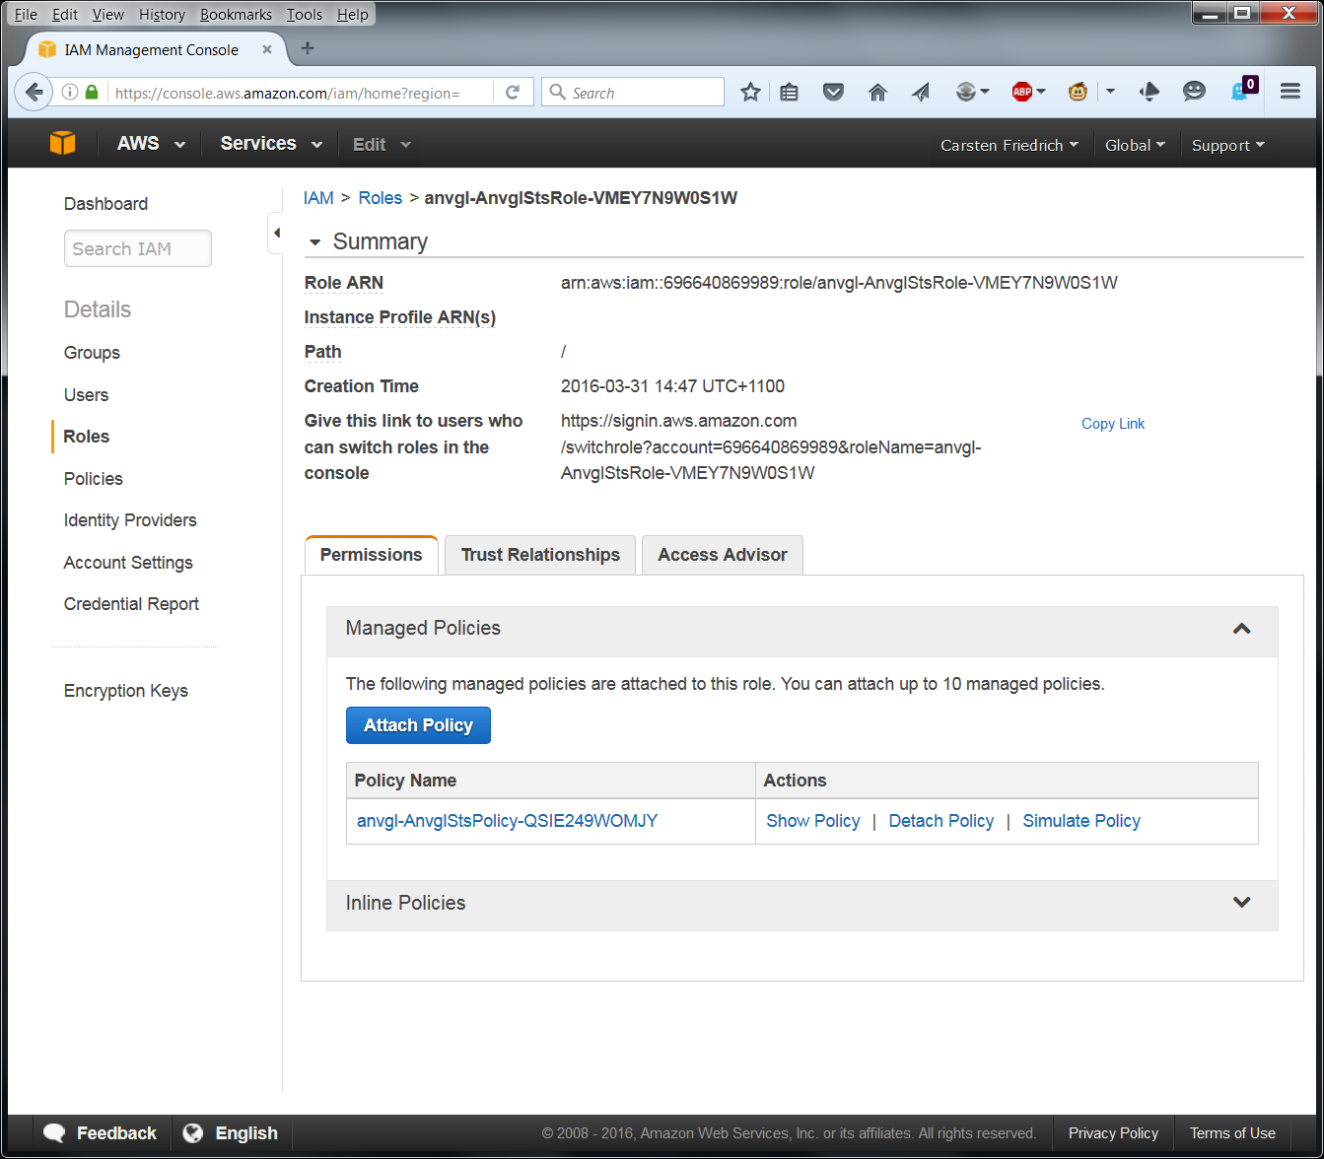

In ANVGL press the button “Save Changes”.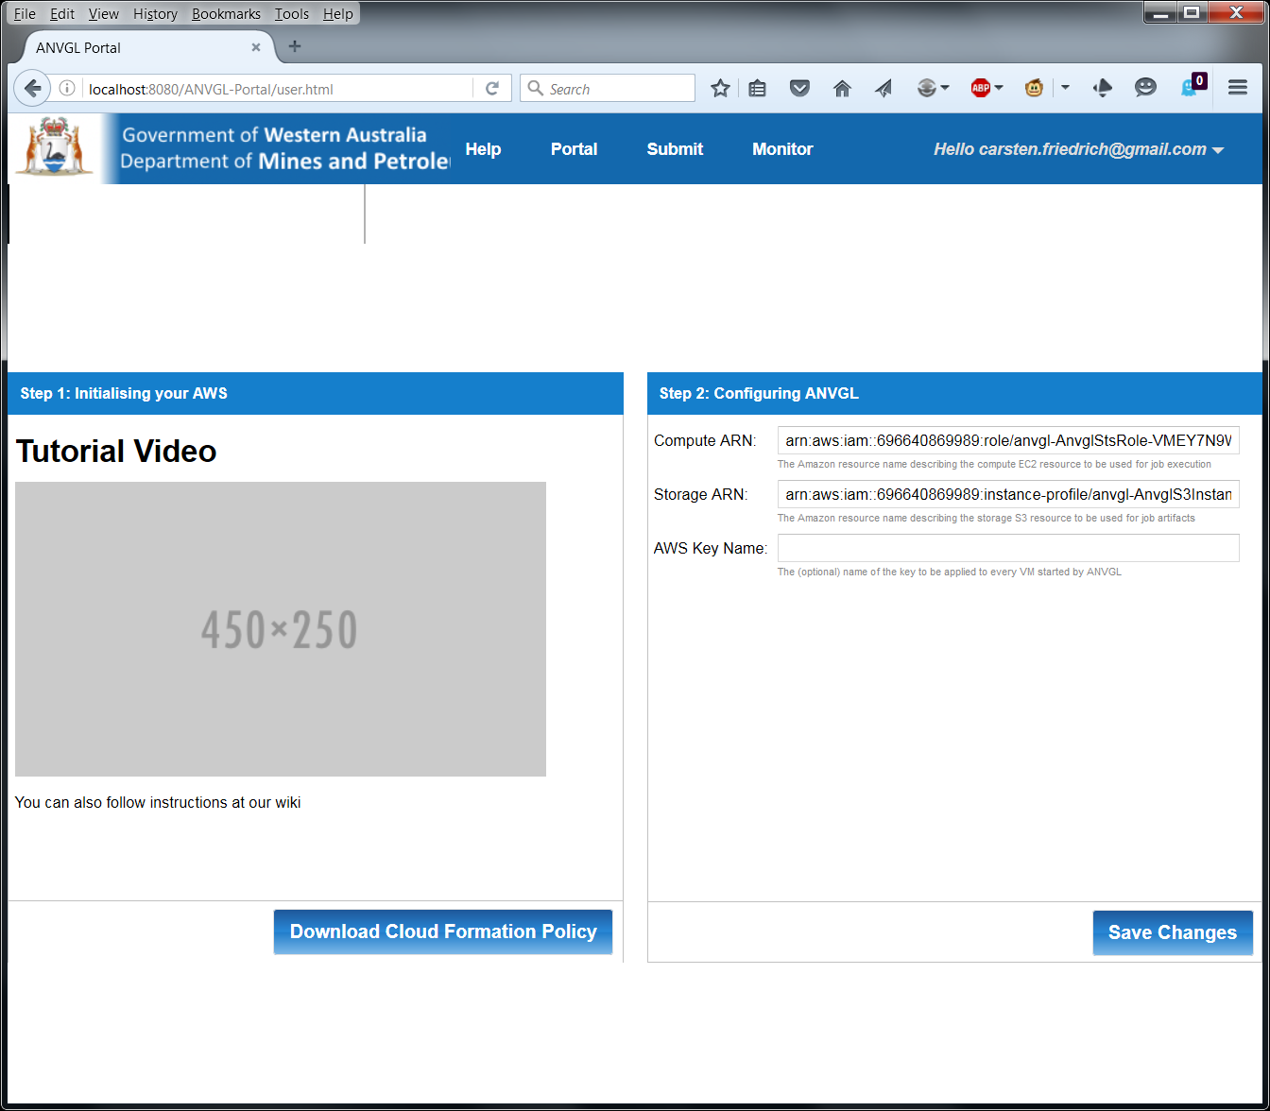

This conclude setting up your ANVGL account and linking it to your Google email and Amazon AWS account. Your ANVGL account is now ready and you can start executing ANVGL jobs.

